CS 255 System Design Document
Melanie Jarrard
Professor Stefanelli
19 June 2026

UML Diagrams

UML Use Case Diagram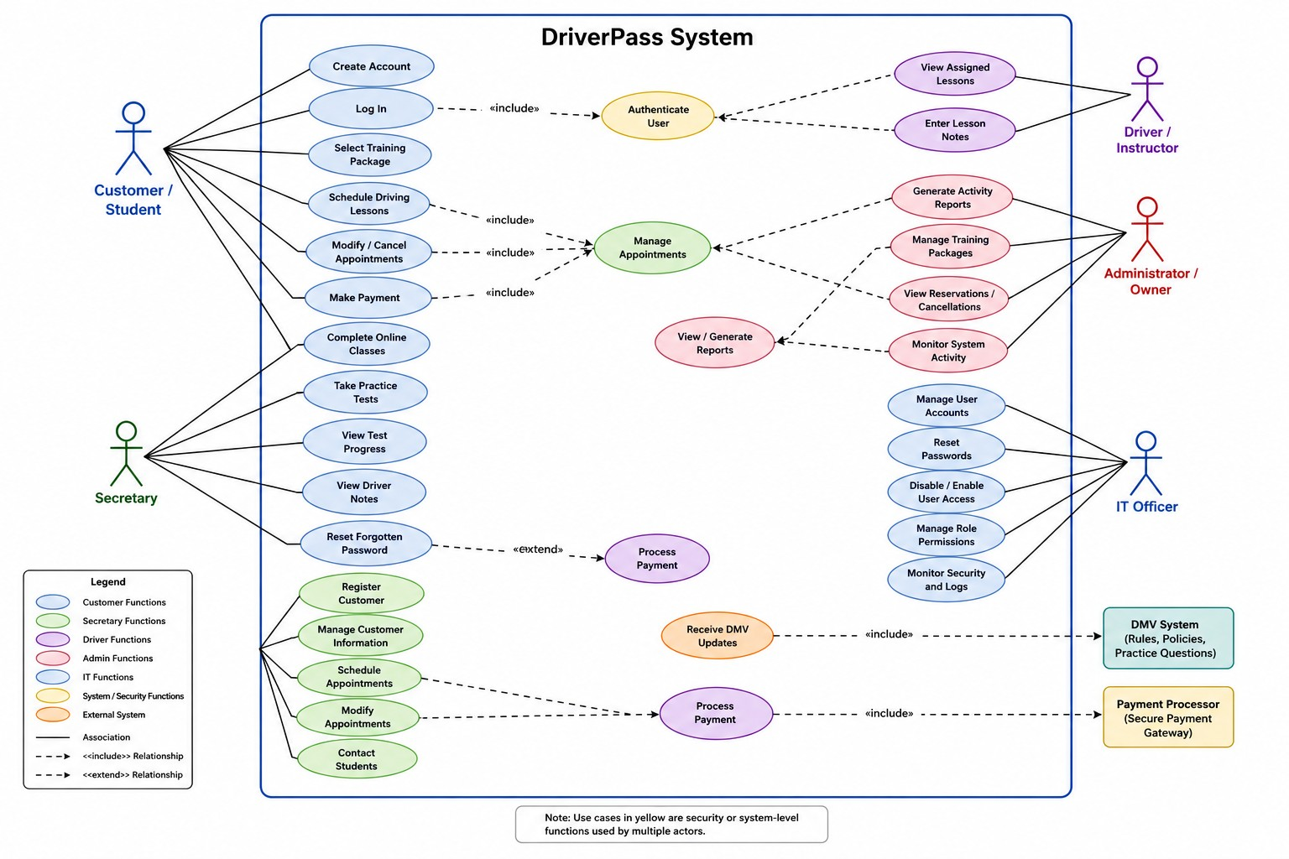

UML Activity Diagrams

Activity Diagram 1 – Schedule Driving Lesson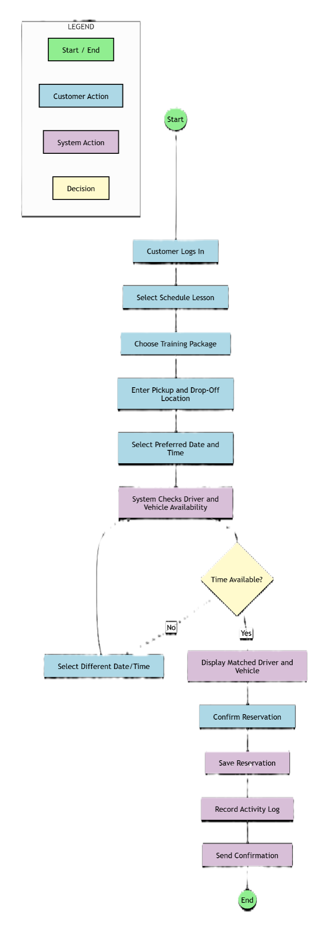

Activity Diagram 2 – Take Practice Test
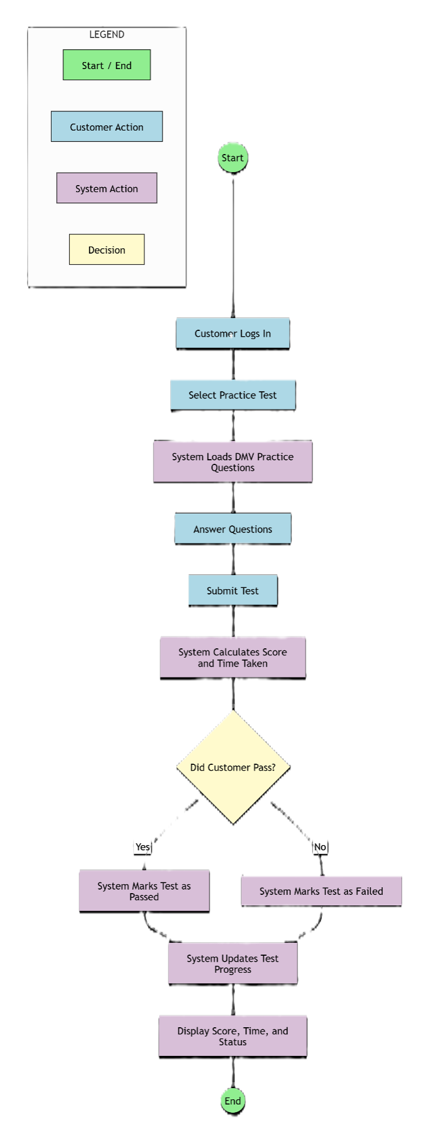

UML Sequence Diagram – Schedule Driving Lesson
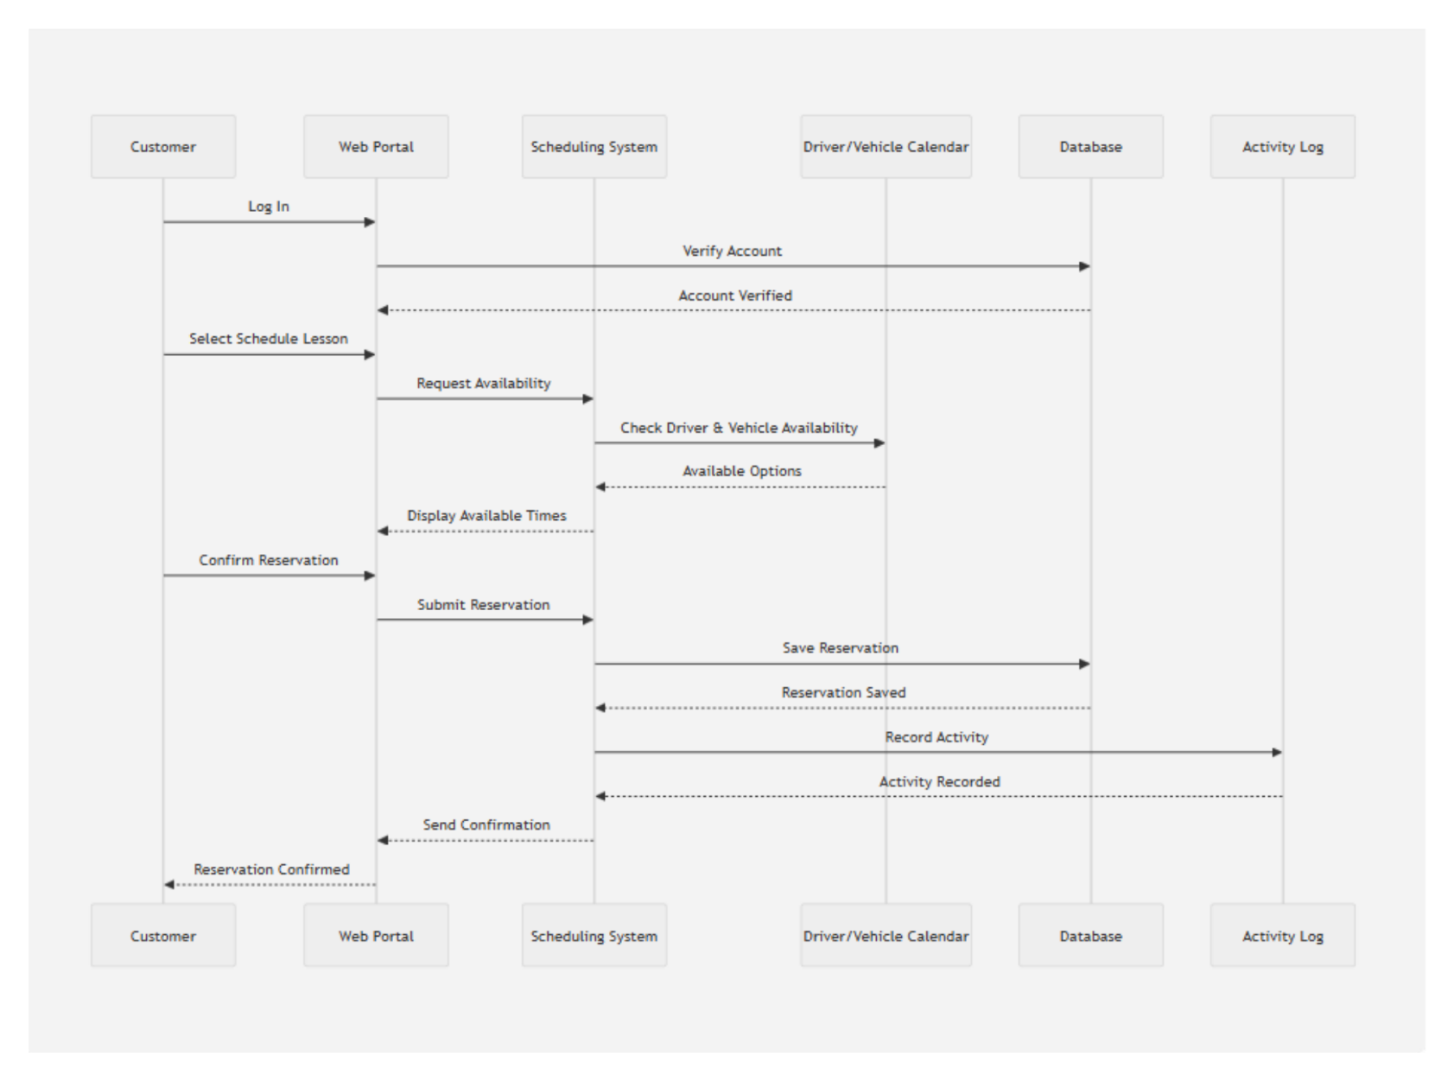

UML Class Diagram
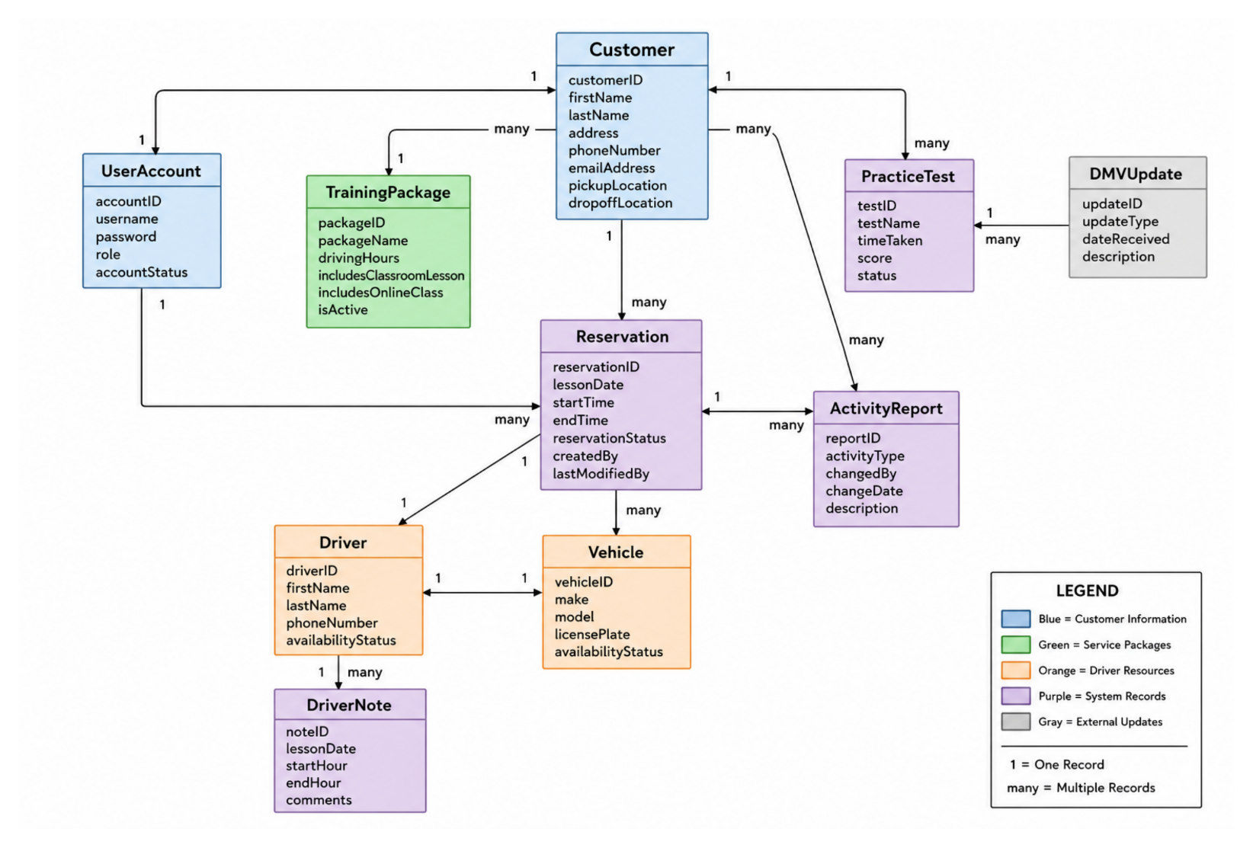

Technical Requirements
Hardware Requirements
The DriverPass system will operate as a cloud-based web application, which reduces the need for specialized hardware at the DriverPass office while still providing reliable access to users. Office personnel, including administrators, secretaries, and driving instructors, will require computers or laptops capable of accessing the internet and running modern web browsers. Customers will be able to access the system using desktop computers, laptops, tablets, or smartphones. Because lesson scheduling, account management, and practice testing occur online, all users must have a stable internet connection. The system will also require cloud-hosted servers to store customer records, reservations, training packages, lesson information, and practice test results. This cloud-based approach supports the client's requirement for a system that can be accessed from multiple locations while minimizing maintenance responsibilities.
Software Requirements
DriverPass requires a web-based software solution that can be accessed through commonly used browsers such as Google Chrome, Microsoft Edge, Mozilla Firefox, and Safari. The application should support multiple operating systems, including Windows, macOS, Android, and iOS, to ensure accessibility for both customers and employees. The system must provide functionality for user account creation, lesson scheduling, online training materials, practice examinations, payment processing, reporting, and administrative management. Integration with external services, including DMV updates and payment processing systems, is also required to ensure that information remains current and that customer payments can be processed securely. Because DriverPass plans to offer online educational resources and practice testing, the software must support the delivery and storage of digital learning content.
Database Requirements
A centralized database is required to manage all information associated with the DriverPass system. The database must store customer account information, training package selections, appointment reservations, instructor assignments, vehicle assignments, online course progress, practice test scores, payment records, and driver notes. Administrative information such as user permissions, activity reports, and system logs must also be maintained within the database. The database should support frequent updates and allow multiple authorized users to access information simultaneously without compromising data integrity. Proper database organization will improve system performance, support accurate reporting, and ensure that customer information can be retrieved efficiently when needed.
Security Requirements
Security is a critical component of the DriverPass system because it stores personal customer information, payment data, and scheduling records. Users must authenticate through secure login credentials before accessing protected areas of the application. Role-based access controls should be implemented to ensure that users can only access information relevant to their responsibilities. For example, customers should not be able to view administrative reports, while instructors should only access lesson-related information. Password recovery functionality should be available to assist users who forget their credentials. Sensitive information should be encrypted during transmission and storage whenever possible. The system should also maintain activity logs that track significant actions performed by users to improve accountability and support troubleshooting efforts.
Infrastructure Requirements
The DriverPass system should be deployed within a cloud computing environment to support scalability, reliability, and accessibility. Cloud hosting allows DriverPass to expand system resources as the number of customers increases without requiring significant hardware investments. Automated backup procedures should be implemented to protect business and customer data in the event of hardware failures, cyberattacks, or other unexpected disruptions. Disaster recovery capabilities should be available to restore operations quickly if service interruptions occur. The infrastructure must also support communication with external systems, including DMV information sources and payment processing services. High availability is important because customers may access the system at any time to schedule lessons, complete online coursework, or review their progress.
Network and Integration Requirements
The DriverPass system depends on reliable network connectivity to support communication between customers, employees, cloud-hosted services, and external systems. Secure network connections should be used when transmitting customer information and payment data. The system must integrate with DMV resources to receive updated driving regulations, policies, and practice test questions. Integration with a secure payment processor is also required to support online purchases of training packages and other services. These integrations ensure that customers receive accurate educational materials and can complete transactions safely through the platform.
User Access and System Management Requirements
The system must support multiple user roles, including customers, secretaries, instructors, administrators, and IT personnel. Each role requires different levels of access and functionality. Customers need the ability to register accounts, purchase packages, schedule lessons, complete online training, and view their progress. Secretaries require tools to manage appointments and customer information. Instructors must be able to view assigned lessons and record lesson notes. Administrators need reporting capabilities and management functions for training packages and reservations. IT personnel require access to user account management, security monitoring, and system maintenance functions. Supporting these role-specific responsibilities helps ensure that business operations remain organized and efficient.

